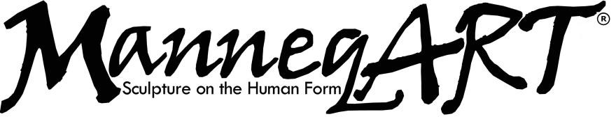

2019 ManneqART® Competition Application Form

- Please fill out a separate form for each artwork you are submitting
- If multiple people are working on a single artwork, only fill out one form. (one entry fee)
- If you are submitting more than one artwork, you must fill out a separate form for each piece. (multiple entry fees)
- If you are entering the Bra Competition, you must fill out a separate form for each entry. (multiple entry fees)

Name

Mailing Address

Phone Email

Artist’s Website (to promote on our website)

Parent/Guardian Name (if under 18 years of age)

Artwork Description

Title of Artwork : _________________________________________________________________________

2019 Theme(s) (See explanation in Rules section)
- Alien
- Insects
- Amphibians
- Found Objects

- I am also entering the Bra Competition
- I am only entering the Bra Competition

Team Members
Who will be working on your artwork? Just yourself? Please list below.

Artist Statement
Please describe the inspiration for your artwork and artistic process in general, and give specific details about your ManneqART® submittal. Include materials, adhesives, structures and any unique processes used. (If your statement exceeds the space given attach additional pages to the form)

Entry Portfolio
See Documentation and File Formatting requirements specified on the ManneqART® website’s General Rules page to photograph your work.
EMAILED (attached .jpg’s with application in an email to (manneqart@gmail.com)
MAILED (enclosed on a CD, DVD, or USB flash drive with application sent by mail)

2019 Deadlines and Entry Fees
Applicants must pay an entry fee for each entry submitted to the ManneqART® Competition. The Bra Competition is a separate entry. Registration fee includes one free copy of annual ManneqART Calendar.
March 30 – Early Bird deadline for application and payment $35 (Student $20)
May 15 – Photos of artwork-in-progress due
May 15 – Final deadline for application and payment $40 (Student $35)
June 15 – Finished artwork due to ManneqART LATE FEE $50 (Student $45)

Fantasy Wood Festival
Applicants who are finished and registered by May 24th are invited to wear their pieces to the 2019 Fantasy Wood Festival! Those who qualify get a free pass for the entire weekend!

Those interested about applying please email us at Manneqart@gmail.com

For those interested in the first Fantasy Wood Festival at Columbia, MD can find out more about the event at fantasywoodfestival.com

Note: To participate, payment must be made on line at manneqart.myshopify.com or by check made out to
____ ManneqART® and mailed to ManneqART by the Application deadline.

Mail to: ManneqART Inc. ® / 9010 Maier Rd. Unit 100 Laurel, MD 20723 (USA)

Rules, Terms and Conditions, Agreement
Before submitting your application to ManneqART®, please review the following:

The ManneqART® Competition Rules

The ManneqART® Competition Terms & Conditions

By checking this box and signing and submitting your application to ManneqART®, you verify that you have read and agree to the ManneqART Competition Rules and Terms & Conditions. You may print or save both documents for your personal records.

Signature: ______________________________________________ Date: _________________________________

Parent/Guardian Signature (if under 18 years of age): _________________________________________________

Online Application Checklist
- This Application form (3 pgs)
- 3-8 Hi-res .jpg images of Artwork
- Entry Fee (via manneqart.myshopify.com)
- Application and Images attached in an email and sent to manneqart@gmail.com

Print Application Checklist

This Application form (3 pgs)

3-8 Hi-res images of Artwork (on CD, DVD, or USB flash drive)

Entry Fee (via manneqart.myshopify.com or by check made out to ManneqART®)
- All included in an envelope and mailed to: ManneqART Inc.® 9010 Maier Rd. Unit 100 Laurel, MD 20723

